GE Washer Breakdown, Analysis, and Proposed Improvements

# Disassembly

To formulate potential business opportunities and future innovation projects with General Electric Appliances, a GE washer, model GTW385ASWWS, was purchased and disassembled to gain a better understanding of the electrochemical components and where JE could provide improvement over the current components and configuration.

## Unit Breakdown

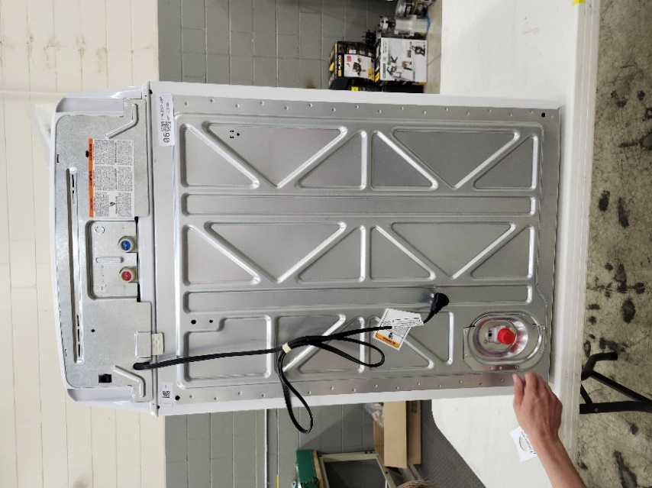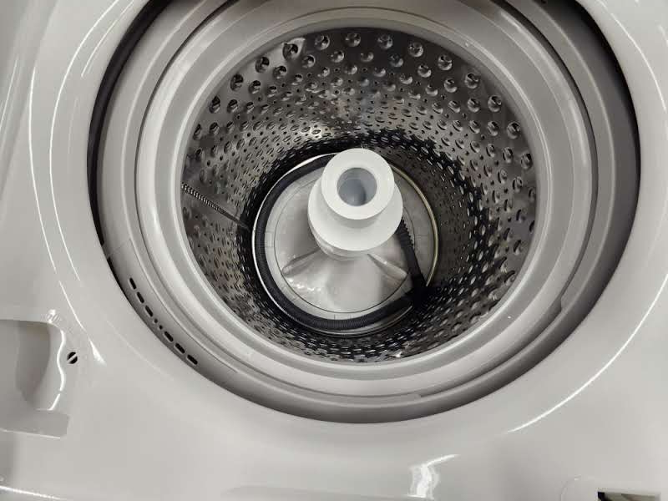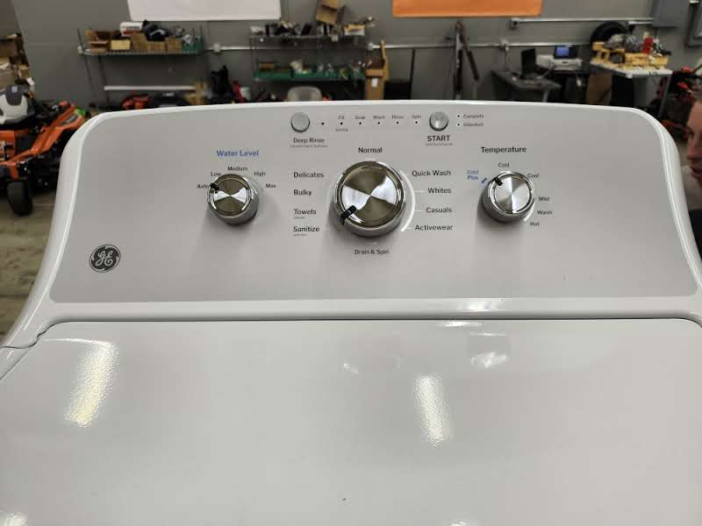

**Washer Model # GTW385ASWWS**

The first two pieces that were removed were backing plates on the washer. These two plates were located (A) at the top of the back of the unit and (B) around the drain outlet at the rear base of the unit. These two pieces were held in with 2 screws each, which were removed and set aside.

B

A

**Location of Backing Plates**

Removing the top panel revealed the control board for the unit as well as two valves used for the the hot (red) and cold (blue) water inlets.

**Control Board and Inlet Valves**

These inlets led directly into the main drum of the washer through a piece of molded plastic.

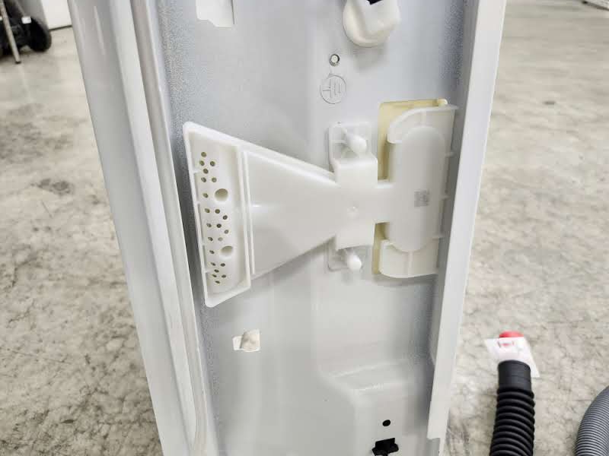

**Water Inlet to Drum**

After this panel was removed, the unit was flipped on its side to access underneath the washer. Interestingly, the bottom of the unit was the only side that was not enclosed in sheet metal. When the unit was flipped, the drain pump (A) and the drive motor assembly (B) could be accessed.

B

A

**Bottom View**

There was a plastic, watertight tub that held the drum and agitator of the washer. This tub was hung in four corners by metal rods, but was able to move around to allow for normal operation and movement of the drum during a wash cycles. Attached to the bottom of the tub were both the drain pump and the entire assembly that contained the agitator, drive motor, and gearbox.

The drain pump was removed by disconnecting the gray connector (circled below) and the three screws that mounted it to the tub. In a similar way, the black cover for the drive motor was removed by undoing the screws that held it in place. This exposed the drive system of the washer and the agitator.

**After Motor Cover Removal**

The remaining wire connectors, for the drive motor, agitator, and speed sensor; were disconnected, the drive motor was then able to be taken off the unit by removing the belt from the two pullys and removing the three bolts that held it in. This left the tub with only a visible pully and the agitator motor. The pully that was attached to the motor doubled as a cooling fan, as well as there being a speed sensor attached to the frame of the motor, as seen below.

**Pully and Fan, Speed Sensor, 3 Phase Drive Motor (top to bottom)**

After this, the agitator motor was disconnected by removing two bolts. This allowed for viewing of the clutch set that allowed the agitator to engage.

**Clutch for Agitator**

Attention was then turned to the top of the unit. The lid was disconnected by removing the two screws that held it in. The one set of wires that was removed ran from the top PCB to the latch (shown below).

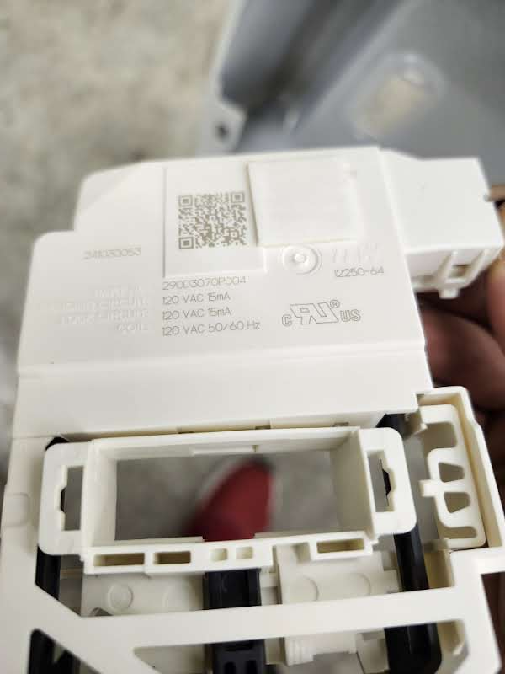 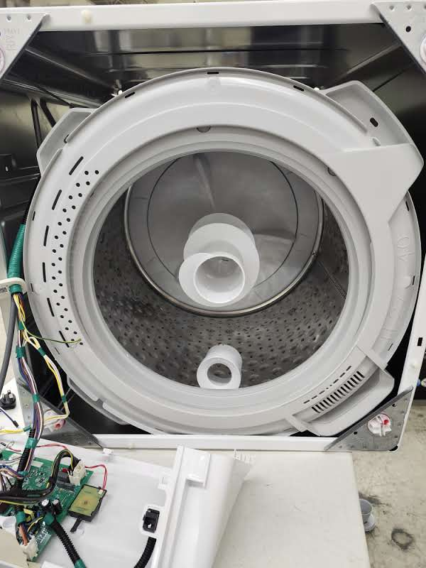

**Latch (Left) After Lid Removal (R)**

There was one tube that was connected from the PCB to the tub. This was believed to be a pressure sensor as it went directly to the PCB, allowing the sensor on the PCB to measure changes in air pressure, which correlates to the amount of water in the unit. After this had been removed, the entire tub was pulled out of the unit, leaving the sheet metal frame. This was done by unhooking the 4 rods the tub was held by from the tub itself and leaving the rods attached to the frame.

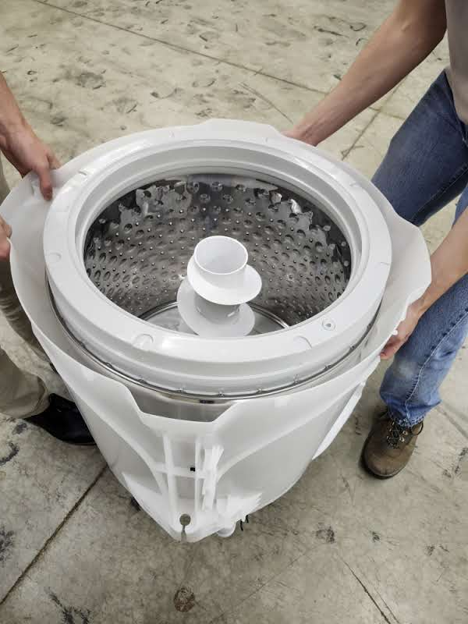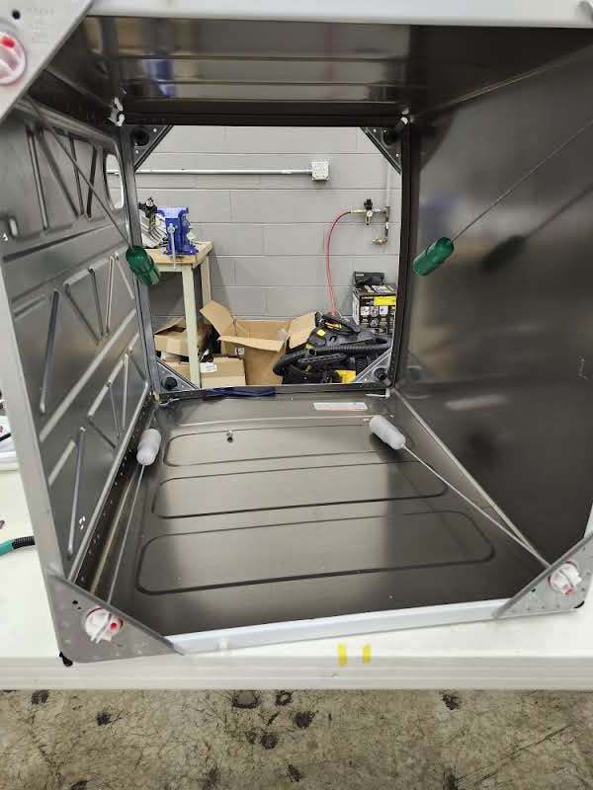

**Tub, Drum and Agitator (L) Empty Shell with Hanging Rods (R)**

The last part that was removed was the assembly on the underside of the tub. The output pully was pryed off the agitator shaft and this allowed the white clutch gear to be removed along. By flipping the underside of these, one could see the teeth that meshed when the clutch wasn’t engaged, allowing the drum and agitator to move in unison. A spring held these two togeather, but when the agiator motor was actuated, an arm moved the clutch to separate the motion of these two parts.

**Output Pully and Clutch Gear (L) Shaft and Spring (R)**

To access the gearbox that drove the drum and agiator, metal rivets were drilled out. These held two pieces of sheet metal togeather on the undeside of the tub. Between these was a set of enclosed plastic gears. To acess the gears, the screws holding the gearbox togeather were removed so the gearbox could be examined.

**Drive Gearbox**

# Sensor, Solenoid, Motor, and Gearbox Breakdown

After completing the breakdown of this unit, all the electrical components were analyzed. It is important to note that all of the components, and therefore the entire unit, use AC power.

## Sensors

### Speed Sensor

**Speed Sensor**

This sensor, attached to the main drive motor, measures the RPM of the rotor. The GE part number is WH03X32158.

### Pressure Sensor

This sensor, which connects to the PCB from the tub via a gray hose, measures the pressure in the tub to determine the water level.

**Pressure Sensor (on PCB)**

### Switch on Agitator Motor

**Switch on Agitator Motor**

This switch is a Toneluck 3 position switch, but only has 2 wires routed to it, in pins 1 and 2. This switch is actuated when the Agitator Motor spins the blue plastic piece so that the tab at the top depresses the switch. It seems that this is to simply give feedback to the PCB as to the state of the agitator, either engaged or disengaged (default state).

## Locks and Valves

### Lid Lock

The lid lock is mounted to the frame of the dishwasher lid. When energized, the black plastic piece is pulled into the white housing. This locks the lid, which contains a plastic loop that fits into the hole, with the black piece. This keeps the washer locked during operation.

**Lid Lock Assembly**

### Inlet Valves

Located next to the PCB behind the top back panel, these two valves are very similar to those found on the GE dishwasher unit. The largest difference, however, is the fact that there are two valves, one for hot and one for cold. These are connected to a single molded piece of plastic that dumps all the water into the washing drum.

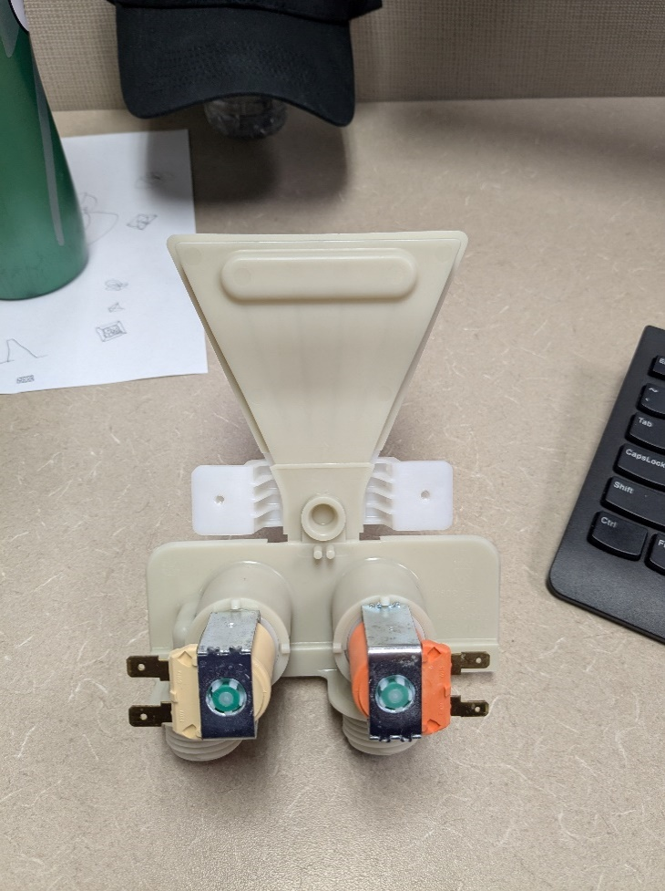

**Inlet Water Valves**

## Motors

### Agitator Motor and Gearbox

The agitator motor assembly is comprised of six pieces, the motor and gearbox, position switch, lever arm, torsion spring, arm ramp, and mounting plate. The motor itself is an AC motor with a built-in gearbox.

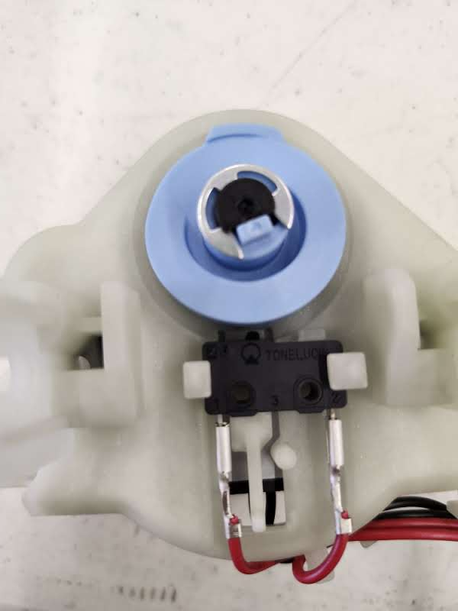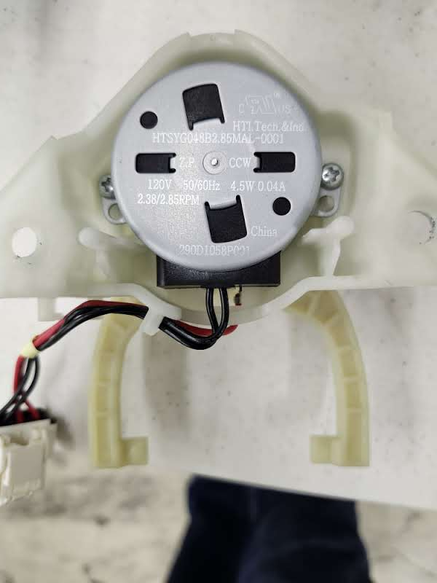

**Top and Bottom View of Agitator Motor Assembly**

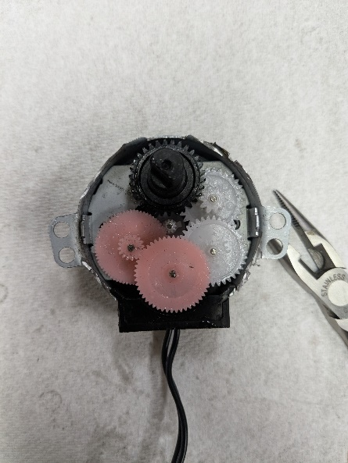The mechanical actuation of the agitator clutch will be discussed more thoroughly in the clutch breakdown section.

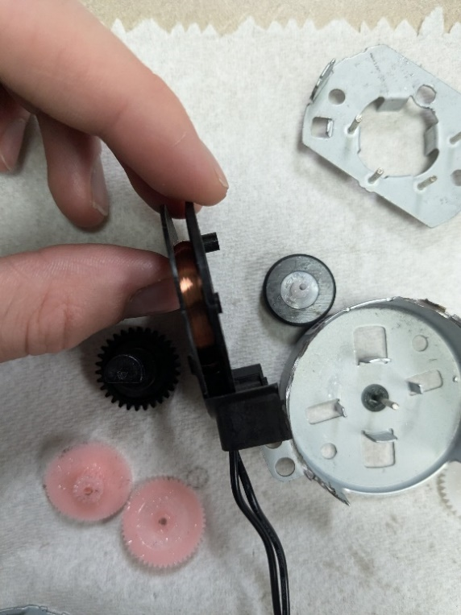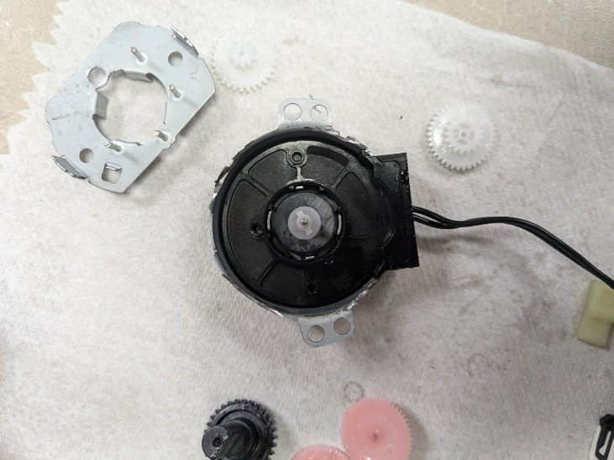**Inside of the Clutch motor**

**Coil and Rotor**

The Clutch motor Contains four compound gears between the drive shaft and the output we believe this is a timing mechanism that times the wash cycle. The motor is wound axial and contains a radially charged magnet as the rotor. There is a stop mechanism that allows it to only spin one way.

### Drum Motor

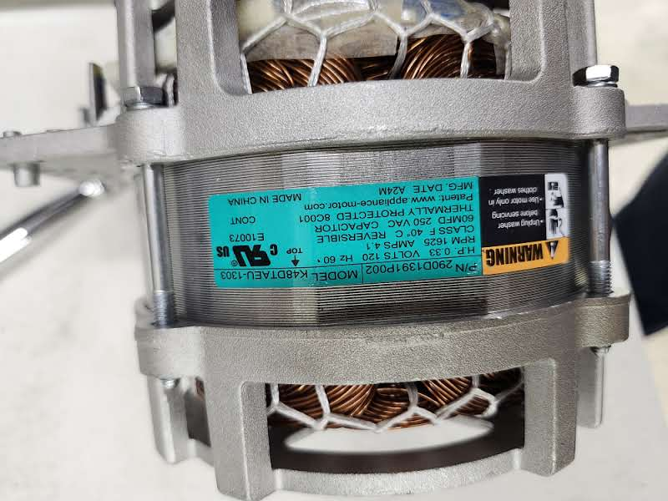

**Specs for Drum Motor**

The motor that drives the assembly is a 3-Phase AC motor. It has a max power output of 1/3 hp. This will be tested on a dyne to observe max torque and characterize the power usage, speed, and torque. The motor is mounted to sheet metal at the base of the tub. There are two other pieces connected to the motor, the speed sensor and the fan/pully. The speed sensor has been discussed above. The fan generates airflow to cool the motor, while the pully is attached to the drive shaft of the drum and agitator. The full assembly can be seen below.

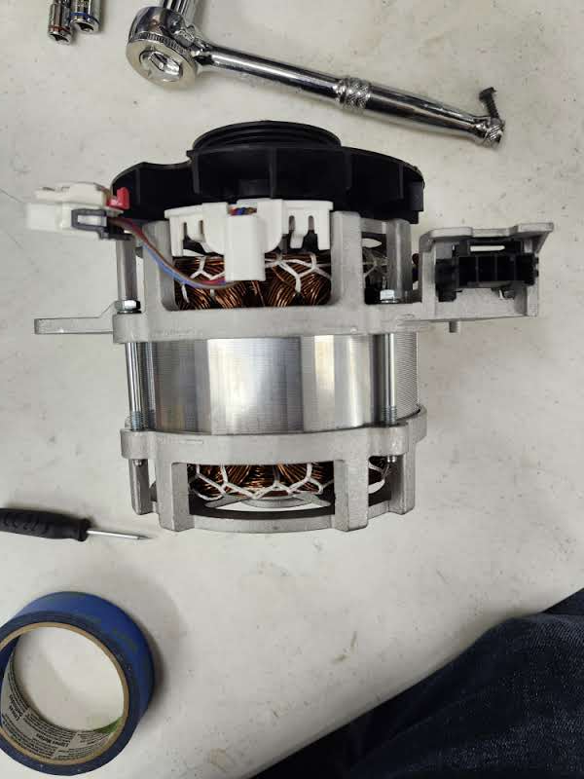

**Motor with attached Components**

### Drain Pump

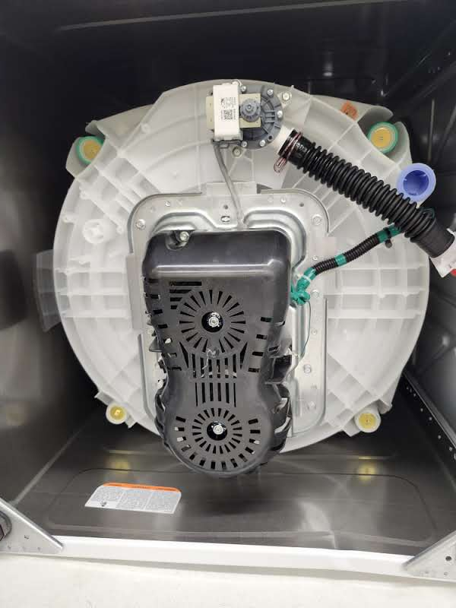

**Drain Pump**

The drain pump is similar to the pump from the GE dishwasher unit. However, the stack size is larger than that from the dishwasher unit. This is due to the need to pump a larger volume of water, as well as needing the ability to pump to a higher location, as washers can be found in basements which results in a larger height differential, needing a stronger pressure to expel the water. The impeller on the pump also only has 4 blades instead of 8, and it does not spiral in a pattern. This may be due to restrictions and tests about strings or linen being caught and tangled in the rotor.

## Gearbox and Clutch

### Drum Gearbox Breakdown

The main drive gearbox is contained between two pieces of riveted sheet steel. Inside this shell is an enclosed planetary gearbox mechanism.

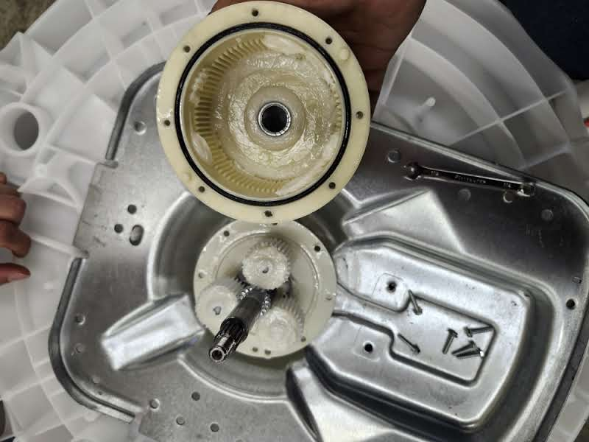

**Gearbox**

This gearbox drives the washing drum. A planetary gearbox containing three plastic gears is used to distribute the weight force needed to spin the drum across three gears. This entire casing spins when the clutch is in the default state. This causes both the agitator and drum to spin. The center shaft contains 19 teeth, the planets contain 36 teeth each, and the outer shell contains 86 teeth. The overall assembly is watertight, and the two sides of the gearbox are attached with screws. There is an O ring that is seated in the plastic shell, and the inside contains lubricating grease. The case connects directly to the drum, and the center metal shaft is connected to the agitator. When the clutch is in the default state, both the outer ring and the sun spin at the same time, resulting in both the drum and the agitator moving. When the clutch is engaged, the radial gear does not move, and only the center shaft and the agitator spin.

### Clutch Breakdown

The clutch system is used to change when the agitator is being used. This clutch is actuated by the agitator motor and gearbox discussed above. When the motor completes half a rotation, the blue piece forces the cantilever arm to move.

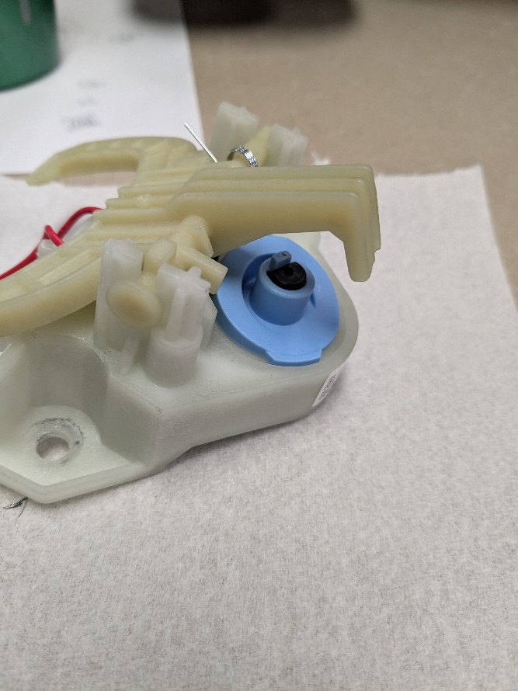

**Motor, Gearbox, and Arm**

The cantilever arm moves a white plastic clutch that is attached to the main drive shaft of the drum. When the clutch is in the default position (seen below) both the drum and the agitator spin from the drive of the drum motor.

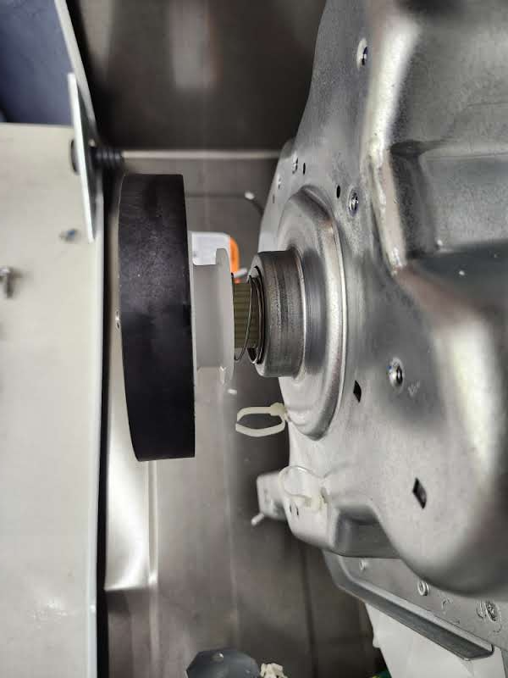

**Default Position of the Clutch**

A spring applies tension to this piece when the arm is not engaging it. When the clutch motor activates, the arm moves the white plastic clutch up. This stops the gear teeth of the white clutch from engaging with those of the black pully (teeth shown below).

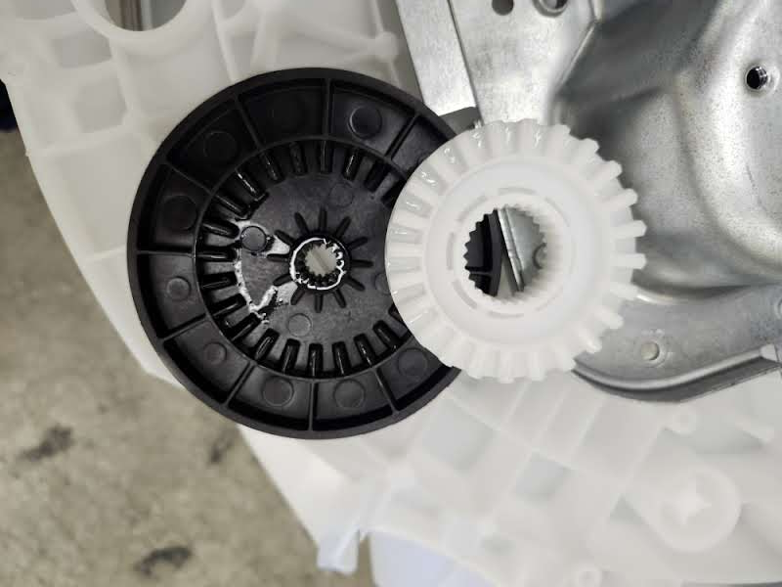

**Underside of Output Pully and Clutch**

When these are not connected, the metal shaft and the plastic shaft (shown below) both do not spin together. This translates to the movement in the drum and the agitator. When the clutch is engaged and the arm pulls the white gear up, only the agitator can spin, and the drum stays put.

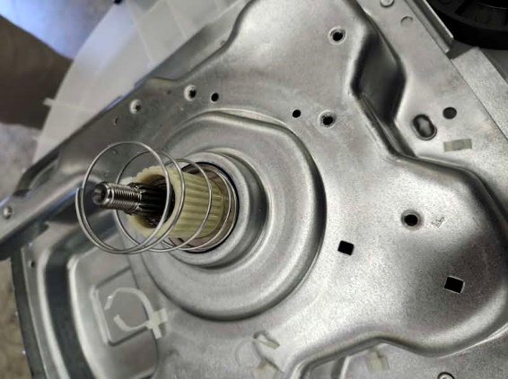

**Drive Shafts and Spring**

# Water Flow Path

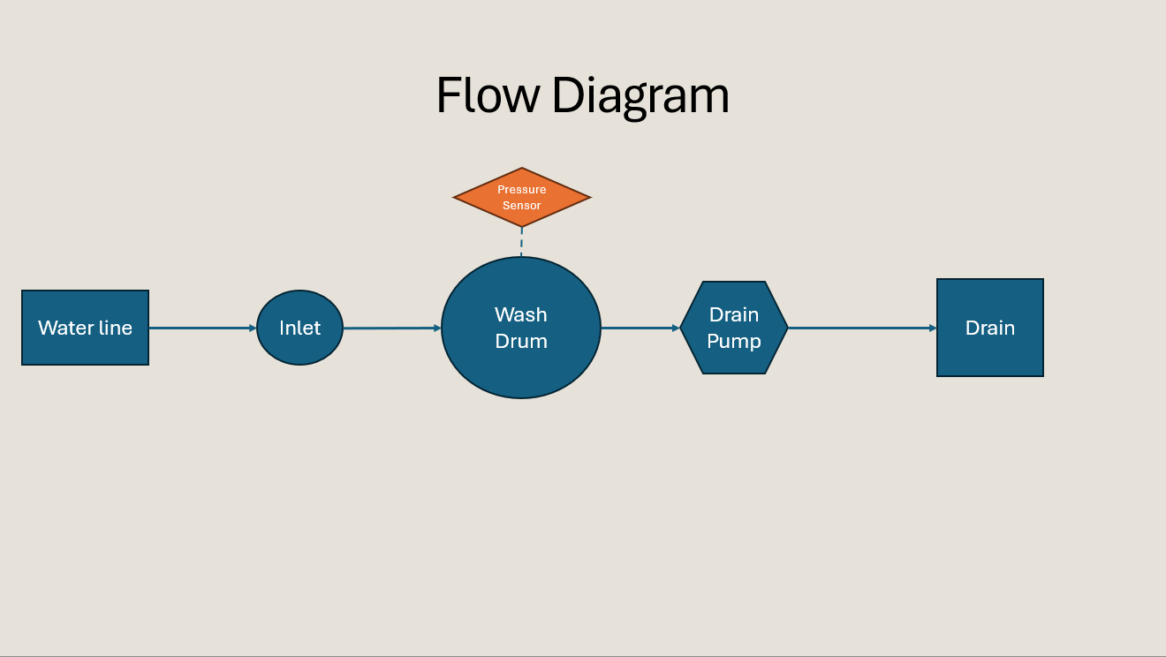

The water inlet has two valves, one for hot water and one for cold. All water flows straight into the wash drum. After a predetermined time based on the wash cycle, the drain pump initiates and sends the water out of the machine.

# Suggested Improvements

We could replace the clutch motor with a solenoid. This would likely be cheaper than the currently used AC motor. A solenoid would also be quieter than a motor, however it may take up slightly more room.

Standardization of the inlet with the dishwasher. We could manufacture the same inlet for the dishwasher and washing machine. Since the washing machine has two solenoids, we would increase volume sold to one per dishwasher and two per washing machine.